Course Three

From Data to Insight: The Power of Statistics
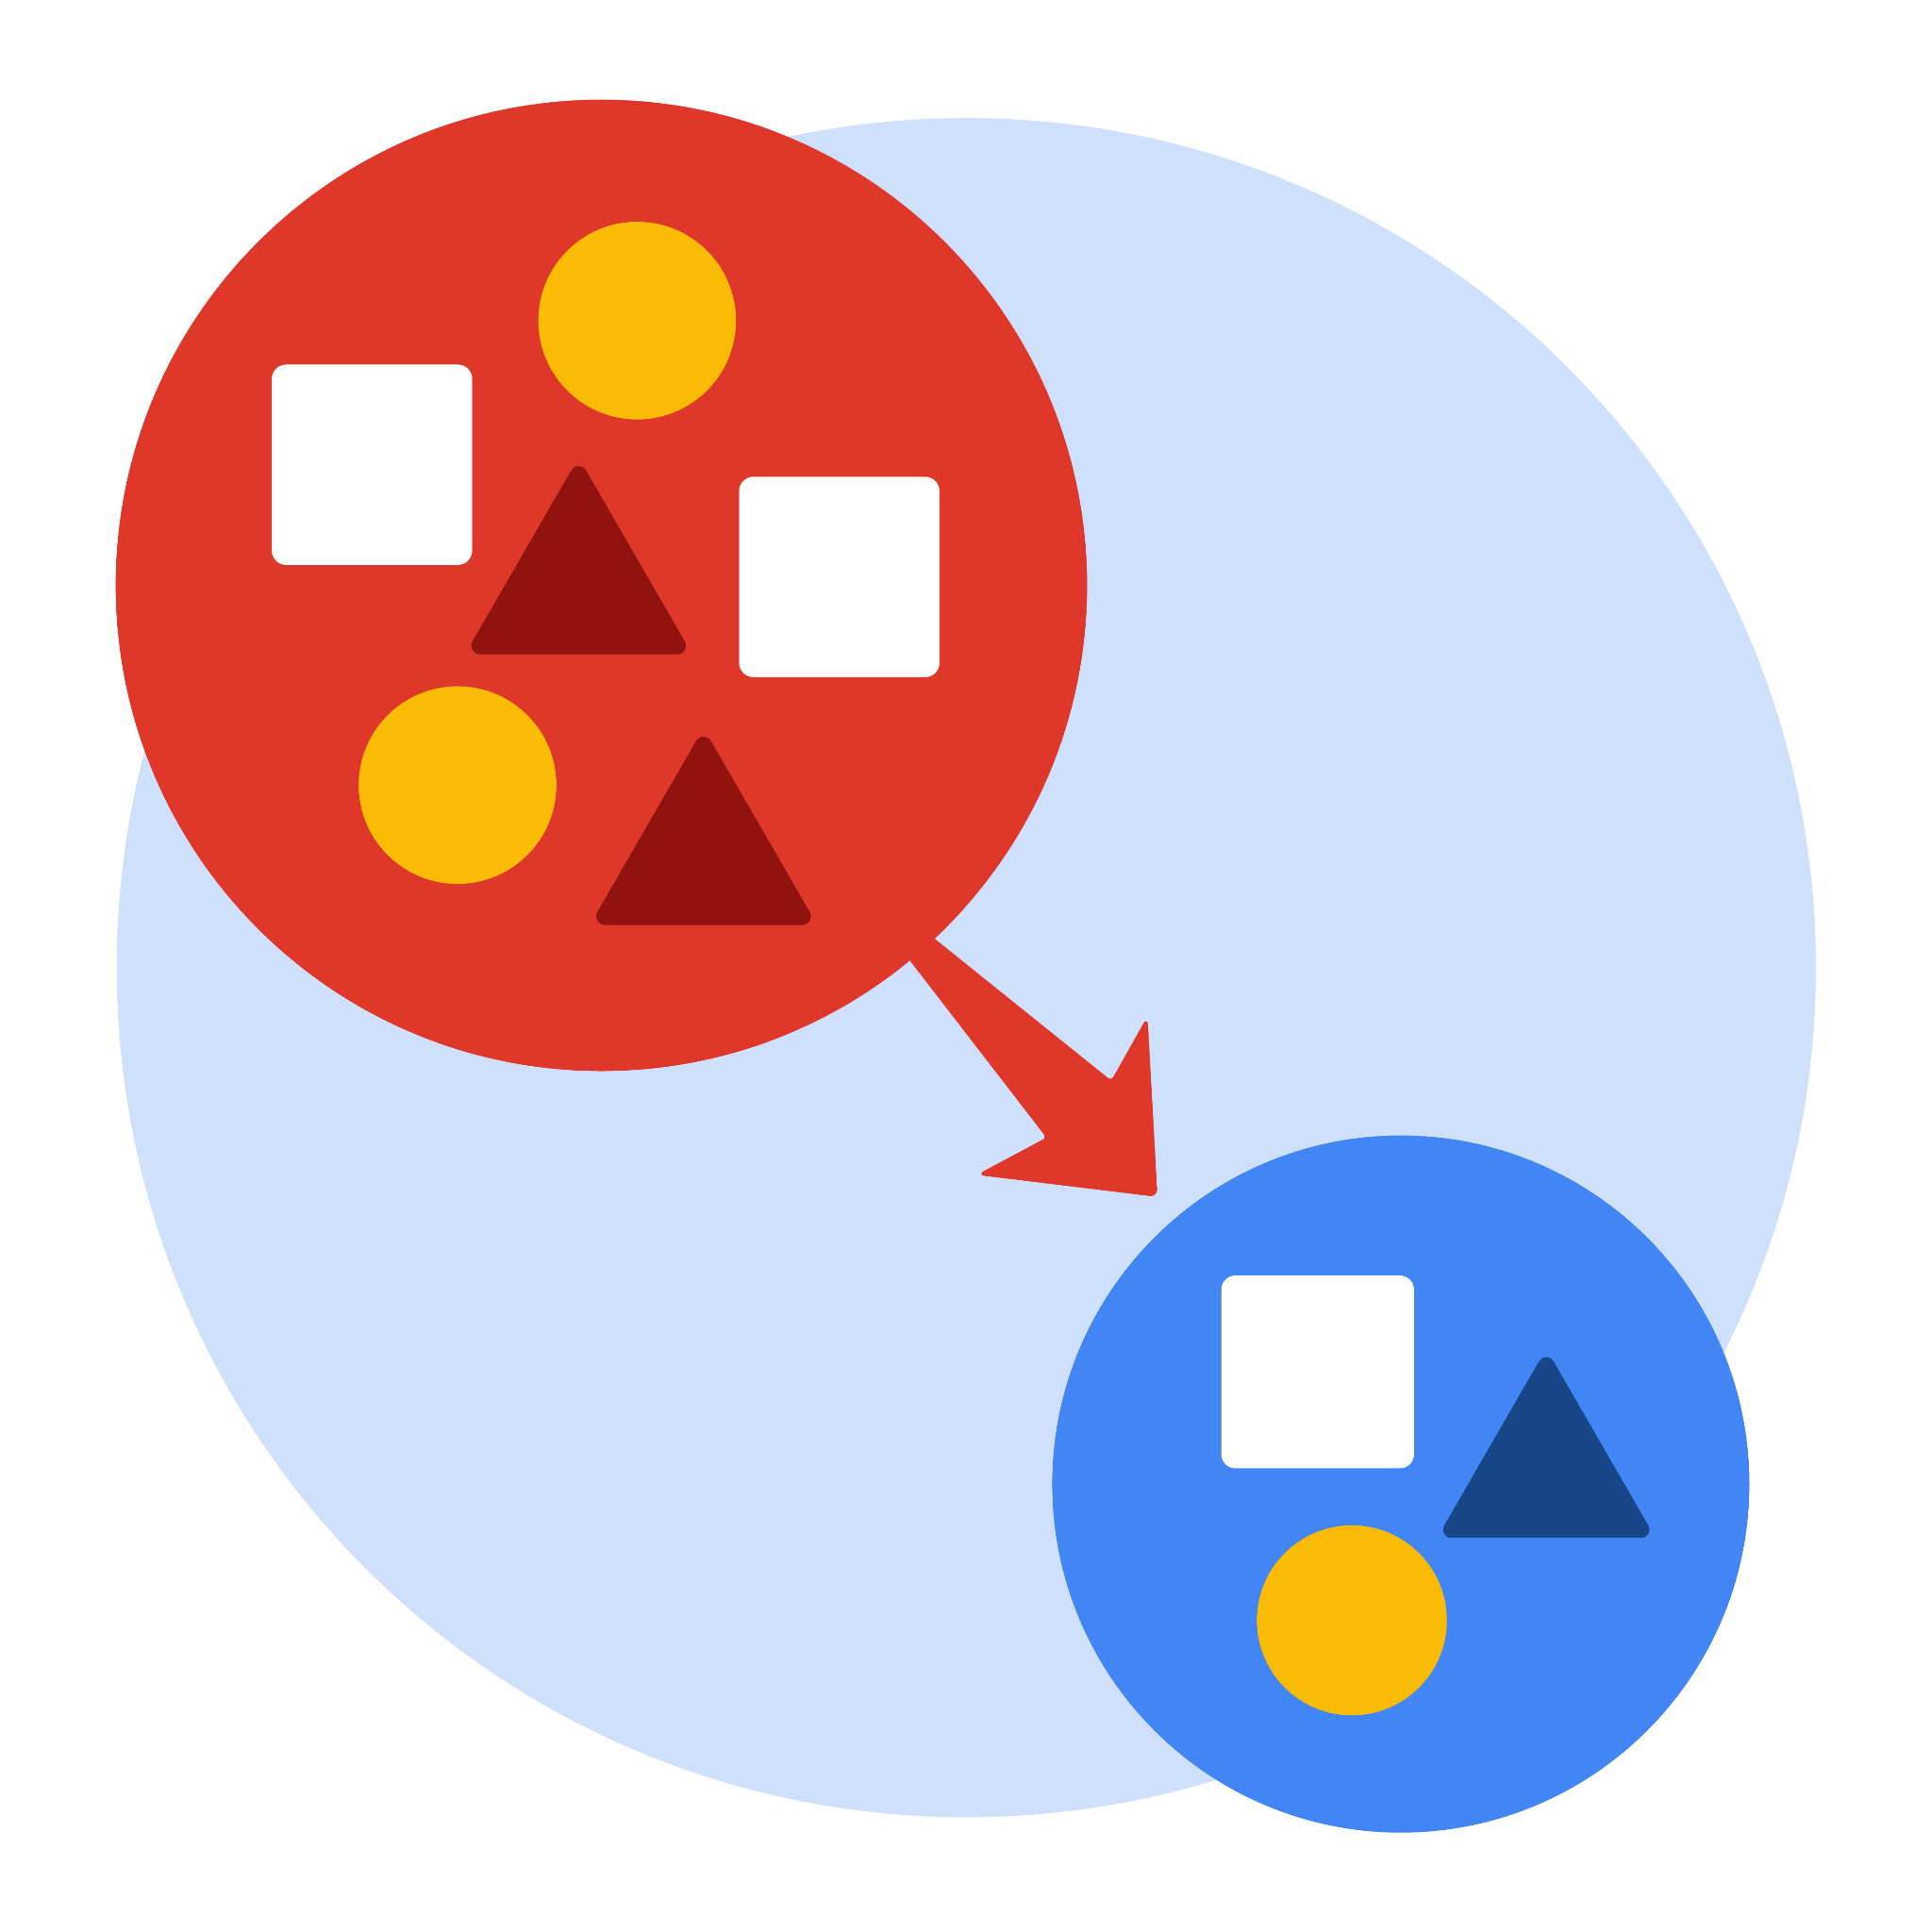

Instructions
Use this PACE strategy document to record decisions and reflections as you work through this end-of-course project. As a reminder, this document is a resource that you can reference in the future, and a guide to help you consider responses and reflections posed at various points throughout projects.

Course Project Recap
Regardless of which track you have chosen to complete, your goals for this project are:
- Complete the questions in the Course 3 PACE strategy document
- Answer the questions in the Jupyter notebook project file
- Compute descriptive statistics
- Conduct a hypothesis test
- Create an executive summary for external stakeholders

Relevant Interview Questions
Completing this end-of-course project will empower you to respond to the following interview topics:
- How would you explain an A/B test to stakeholders who may not be familiar with analytics?
- If you had access to company performance data, what statistical tests might be useful to help understand performance?
- What considerations would you think about when presenting results to make sure they have an impact or have achieved the desired results?
- What are some effective ways to communicate statistical concepts/methods to a non-technical audience?
- In your own words, explain the factors that go into an experimental design for designs such as A/B tests.

Reference Guide
This project has four tasks; the visual below identifies how the stages of PACE are incorporated across those tasks.


Data Project Questions & Considerations

PACE: Plan Stage
- What is the main purpose of this project?
To demonstrate knowledge of how to prepare, create, and analyze hypothesis tests with the given TikTok dataset

- What is your research question for this project?
Do videos from verified accounts and videos from unverified accounts have different average view counts?

- What is the importance of random sampling?
Random sampling allows the sample to be evenly distributed without any potential bias

- Give an example of sampling bias that might occur if you didn’t use random sampling.
Undercoverage bias might occur when conducting hypothesis testing if certain parts of the sample population have no chance of being selected.

 PACE: Analyze & Construct Stages
- In general, why are descriptive statistics useful?
Descriptive statistics are useful because they allow me to quickly understand and extract meaningful information from large amounts of data.

- How did computing descriptive statistics help you analyze your data?
Descriptive statistics helped me compute the mean and range of video_view_count values for each group of verified_status in the sample data.

- In hypothesis testing, what is the difference between the null hypothesis and the alternative hypothesis?
The null hypothesis is the hypothesis that is assumed to be true, the alternative hypothesis is the hypothesis challenging the null hypothesis and requires statistical significance to validate.

- How did you formulate your null hypothesis and alternative hypothesis?
I selected the variables related to my hypotheses, namely `verified status` and `video view count`, then I formulated the null hypothesis to assume an equal view count on average for authors of verified and unverified status, and the alternative hypothesis to predict an unequal view count.

- What conclusion can be drawn from the hypothesis test?
The hypothesis test proves the alternative hypothesis.

PACE: Execute Stage
- What key business or organizational insight(s) emerged from your A/B test?
Since there is a statistically significant difference in the average view counts between videos from verified accounts and videos from unverified accounts, it would be interesting to investigate the root cause of the underlying behavioral differences, which could be, for instance, clickbait or spam bots from verified accounts to inflate view counts.

- What recommendations do you propose based on your results?
A regression model for verified_status can help analyze user behavior in the group of verified users. Due to the imbalance in account types demonstrated in this lab, a logistic regression model might be more appropriate to negate outliers.

